FYP interim report

Liang Shi Lin, Bob - IEM y4

1. **Introduction**
   1. **Project background**

As more and more people are recognizing the importance of taking care of their personal health, an application that helps to keep track of all the personalized health information and provides healthy living recommendation and tips would make it much easier to maintain a healthy lifestyle. The problem with apps on the market right now is there are many aspects to taking care of health, such as fitness, nutrition and supplementation. However, most apps only manage one aspect of healthy living.

* 1. **Objective**

Therefore, the objective of this project is to design an all-in-one mobile application that is capable of tracking users' healthcare records, nutrition plans and exercise schedules while also be able to give personalized tips on healthy living practices. Gamification will also be applied to this application where users can compete against each other and complete challenges to enhance the user experience and make the process more entertaining.

* 1. **Scope**

Through this project, I hope to demonstrate my ability in front end software engineering through producing a market ready mobile application. Therefore, I will be using multiple different tools and programming language to create this application.

**Front end:**

For this project, Flutter will be used as the main software development framework. It is a new development kit created by Google in recent years that operates on the programming language Dart. It has become commonly used for new software development projects among tech companies for its compatibility across multiple platforms.

**Back end:**

After creating the baseline structure for my application, I will be using Firebase to store the database required to connect to my application. It is a free online database service hosted by Google which is often used in couple with Flutter developed application.

**Graphics:**

Besides the functionality of the application, I will also be working on the consistency of the whole application’s user experience by customizing the graphic components being used in this application with Adobe tools such as Photoshop and After Effects.

1. **Work done so far**
   1. **Wireframing and architecture design**

Before starting with the development of the application, a planning process is required to determine and finalize the interface design and necessary functions to be included within this application.

To produce the application as it is intended, Here are the main functionality that will be included:

**Registration:**

Users are able to create their own accounts and update their personal information such as height, weight, dietary restrictions and fitness goals to the database. Therefore, the system is able to suggestion personalized fitness recommendation to each users based on their personal information.

**Health information tracking:**

Users are able to update their weight daily, and count their calories intake. These are essential information to keep track of in order to maintain their fitness goals. Users are also able to set thresholds and daily targets such as water, calories intake, hours spend on exercising and hours of sleep. These functions all helps to simplify the fitness tracking process.

**Fitness planning:**

There are a list of workout programs and exercise routines curated by professionals to cater to different type of users depending on their fitness interest and goals. Allowing the users to follow a pre-designed routine makes it easier to keep up the good habit of exercising a sufficient amount of time weekly.Users who are of a high experience level will also be able to customized their own routine to follow.

**Dietary suggestions:**

Based on users input, the application is able to suggest a customized diet plan for the users. It accommodates to their dietary restrictions and fitness goals, whether to lose weight to build up their strength or cardiovascular endurance. It also takes into consideration the macro-nutrients and calories intake of the user for the day, to suggestion a meal that can fill up the user’s daily dietary goals.

**Challenges and leaderboards:**

This is the gamification portion of the application where the goal is to engage the users by providing an element of fun through fitness challenges within the community. There are different type of fitness challenges that last for a limited amount of time where users are able to compete against each other.

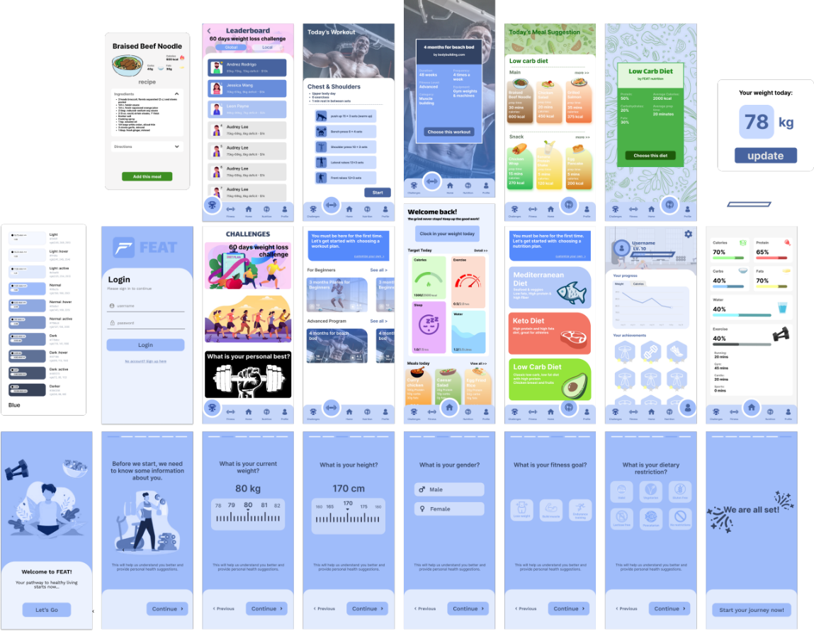

Fig. 2.1 Wireframing prototype

* 1. **User experience design**

When designing the application , there are a couple of factors to consider to optimize the user experience for this application:

**Usability:**

To create an optimal user experience for any application, it is important to start with the navigation and structure which forms the base of a interface model. If an application has faulty structure and it is hard for a user to navigate through the application without guidance, the application has already failed to appeal to its user. There fore it is essential to have very clear call-to-action and it is straightforward to understand how to use the application.

**Consistency:**

It is important to keep the consistency of the appearance throughout an application in order to make an application appear more professional and more pleasant visually. This is achieved through having a universal color theme and similar components throughout the application.

**Accessibility:**

It is also important to have minimal complexity where users are able to achieve their intention with the least amount of actions possible.The idea is to make navigation as simple as possible while maintaining the functionality. This will ensure accessibility is maximized where users have easy access to all features and information while keeping the process fluent.

* 1. **Branding and appearance design**

Therefore, to align the application’s appearance with its objective of promoting a healthier lifestyle, I have came up with an design that is consistently reflective of that goal.

**Brand:**

The name of this application is ‘**FEAT**’, which is a word join by the two factors of a health lifestyle, fitness and eat. The idea is that both exercising regularly and having a healthy diet and good nutrition is equally important in contributing to benefiting personal health.

The word ‘feat’ also means an extraordinary achievement or a remarkable act. Suggesting that accomplishing a personal fitness goal is a success to be celebrated, therefore empowering and engaging the users to pursue for a better personal health.

The logo also reflects that same idea where the alphabet ‘F’ is constructed by 2 lines. The edgy line represents fitness because the sharp and dynamic edges symbolizes the active and dynamic nature of fitness activities. The curved and fluid line represents nutrition where a healthier diet is able to provide a person with better blood circulation and fluidity in their body which leads to overall wellness.



Fig. 2.2 Logo design

**Color theme:**

The overall appearance of this application takes up a generally blue color theme. This is because blue is a color that is able to promote a sense of calmness and tranquility, thus stimulating the mind and clear one’s thoughts. This helps a person to focus and concentrate on the task at hand, and it is able to stimulate one’s productivity.

As this application promotes making healthy living a habit, this color contributes to that goal by encouraging the users to build these habits into a routine and maintain a healthy way of living.

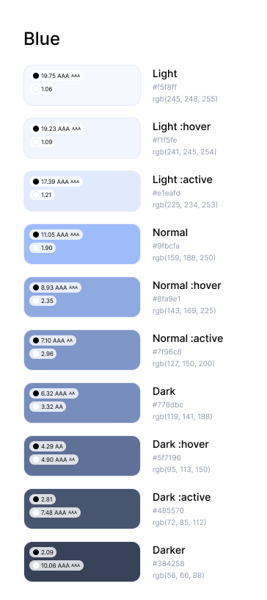

Fig. 2.3 Color theme

* 1. **Front end development**

I have not completed the front end development of this application. It is currently at around 70% completion.

1. **Future work**

After finishing up developing the application, I will start with setting up the database for this system, and then connect it to the client.

Once the application is fully functional, I will be working on the user experience aspects with the addition of transitions and animations to make the application more professional.